Hositing function :-

Html code

<!DOCTYPE html>

<html lang="en">

<head>

    <meta charset="UTF-8">

    <meta name="viewport" content="width=device-width, initial-scale=1.0">

    <title>Document</title>

</head>

<body>

    <script src="/fun1/index.js"></script>

</body>

</html>

JavaScript code

//using Hositing Function

hositingFunction();

function hositingFunction(){

    console.log('hi hositing function');

}

Output



Named function assignment

//using Hositing Function

hositingFunction();

function hositingFunction(){

    console.log('hi hositing function');

}

//named function assignment

let stand=function walk(){

    console.log('hi named function assignment');

}

stand();

let jump=stand;

jump();



Special objects - arguments

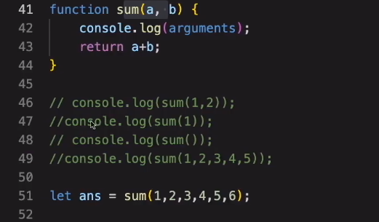

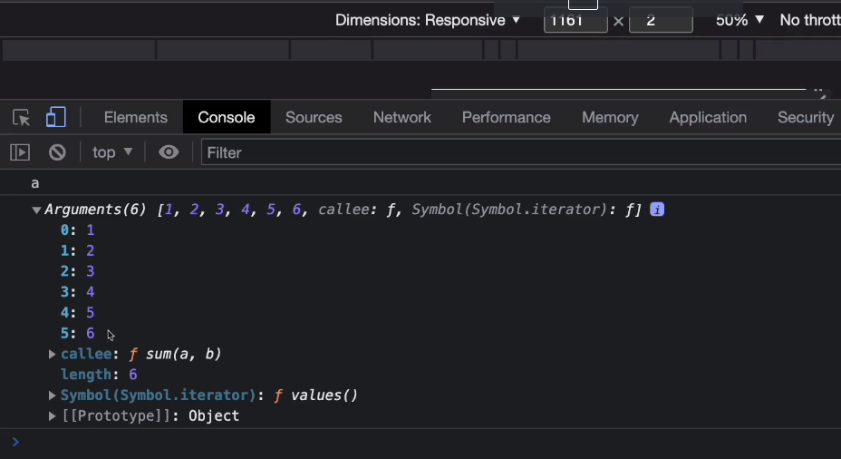

Sab value arguments mai hoti hai

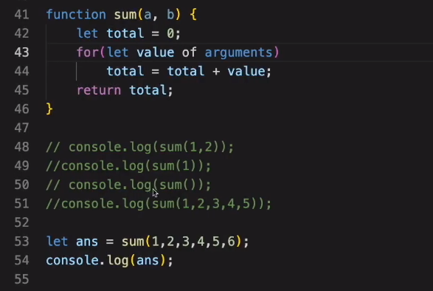



Arguments

function sum(a,b){

    let total=0;

    for(let value of arguments){

        total=total+value;

    }

    return total;

}

let total=sum(1,2,5);

console.log(total);



Rest parameter

//rest parameter

function sum(...args){

    console.log(args);

}

sum(1,2,3,4,5,6,2);

function rest1(a,...args){

    console.log(args);

}

rest1(1,2,3,4,5,6,2);

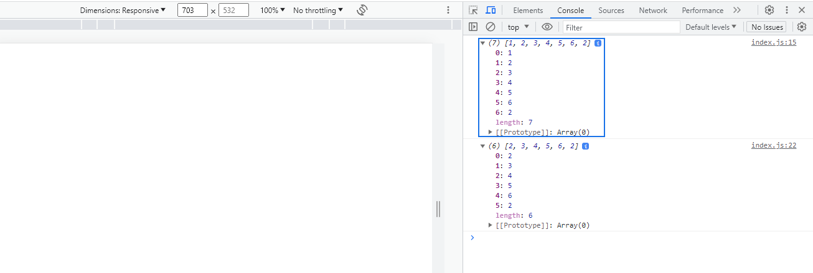

Default parameter

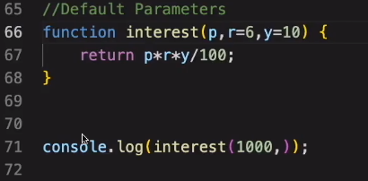

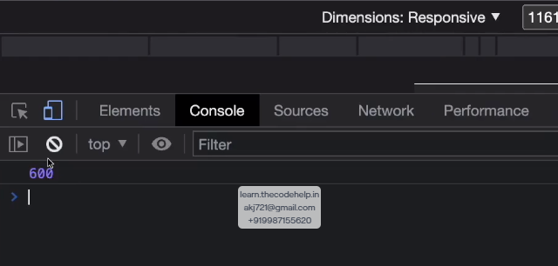

Getter and Setter

let person={

    firstName:'anand',

    lastName:'kumar',

    get fullName(){

        return `${person.firstName} ${person.lastName}`;

    },

    set fullName(val){

        let parts=val.split(' ');

        this.firstName=parts[0];

        this.lastName=parts[1];

    }

};

console.log(person.fullName);



let person={

    firstName:'anand',

    lastName:'kumar',

    get fullName(){

        return `${person.firstName} ${person.lastName}`;

    },

    set fullName(val){

        let parts=val.split(' ');

        this.firstName=parts[0];

        this.lastName=parts[1];

    }

};

person.firstName='trisha';

person.lastName='krishnan';

console.log(person.fullName);



Try catch

let person={

    firstName:'anand',

    lastName:'kumar',

    get fullName(){

        return `${person.firstName} ${person.lastName}`;

    },

    set fullName(val){

        if( typeof val!==String){

            throw new Error("you have not sent words ");

        }

        let parts=val.split(' ');

        this.firstName=parts[0];

        this.lastName=parts[1];

    }

};

try {

    person.fullName=true;

} catch (e) {

    alert(e);

}

console.log(person.fullName);



Reduce

//reduce

let arr=[1,2,6,5];

let total=arr.reduce((val1,val2)=>val1+val2,0);

console.log('total is ' +total);



